Ridhwaan Ali

Challenge 4

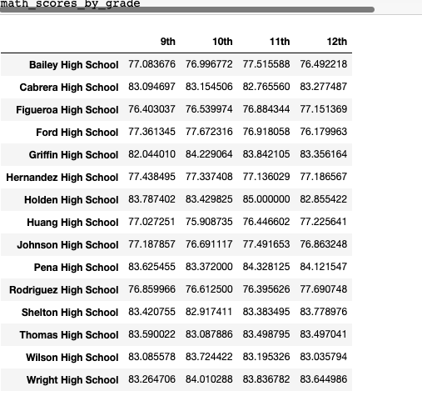
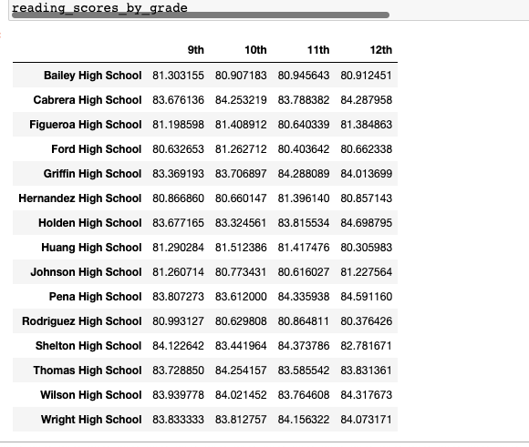
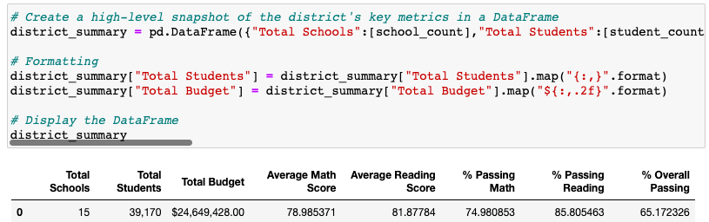
Based on my observations in the district summary dataframe it shows that 65% of the students overall have passed and majority of it seems to be in correlation with the averages of the reading scores. In the math scores data table I do notice that the average math scores number is lower mainly because it seems to show that 9th graders are within that high 70 range; however, by the 12th grade they have improved their scores.

